



Contents

Group Members 1

Who is your audience? 2

Selected Dataset 2

Question(s) you will be answering? 2

Analyses 2

Selected Predictive Model 2

Selected Visualization 3

Finding(s) 3

Recommendation(s) 3

What is at stake? 3

References 3

**Note: remove instructions in red fonts before submitting**

# Who is your audience?

List the primary groups or individuals to whom you will be communicating.

*Business person*

*Person who travel frequently*

*Person who want to spend their travel points*

*Person who travel long distance*

*I would like to to present my analysis to an airline tickets agent*

If you had to narrow down to a single person, who would that be?

Business person who travel alot for work

What does your audience care about?

*Seat comfort*

# Selected Dataset

Airline Customer Satisfaction

The data set

Airlines_dataset_filtered

contains responses from a survey evaluating customer

satisfaction with their airline travels. The data were collected from the website with the URL. The

metadata is given in the table below.

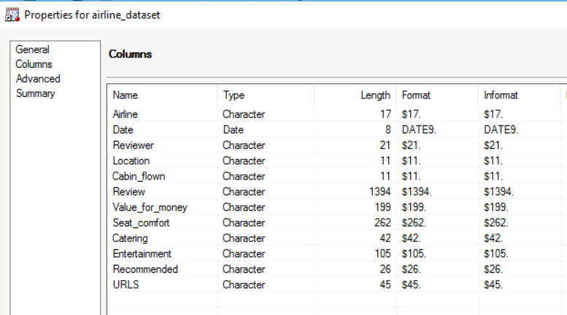

# Question(s) you will be answering?

*How to find the best seat comfort that is available for customers.*

How should customers spend their travel points?

How to get away from anxiety from a long distance?

How to get away from anxiety from traveling frequently?

# 

# 

# 

# 

# 

# 

# Analyses

## Selected Predictive Model

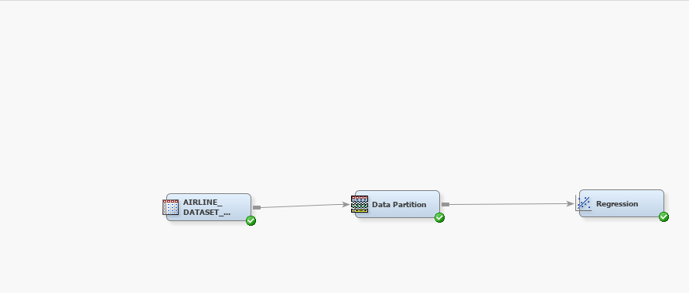

Required sections for the final model (note: you may have to build several models, but here, just report the final one)

|  |  |  |
| --- | --- | --- |
| Logistic Regression |  |  |
| * Selected Variables are cabin_flown, catering, and Value_for_money * Analysis Detail: Data Partition: 50 training, 50 validation, Selection Method is backward * odds ratio is greater than 1, event classification table is below, and assessment score ranking is below |  |  |

## Selected Visualization

Business class in Cabin_flow is statistically significant on an increase of seat comfort

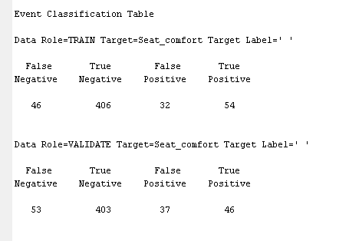

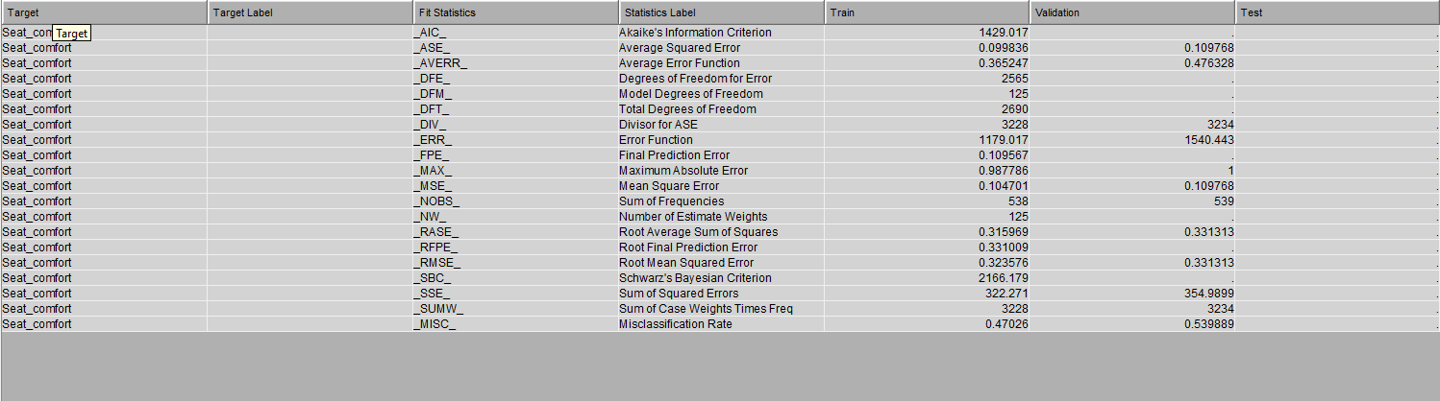

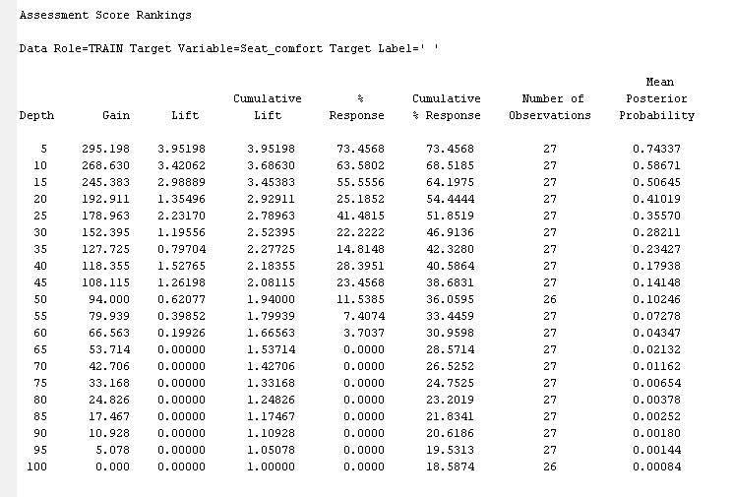

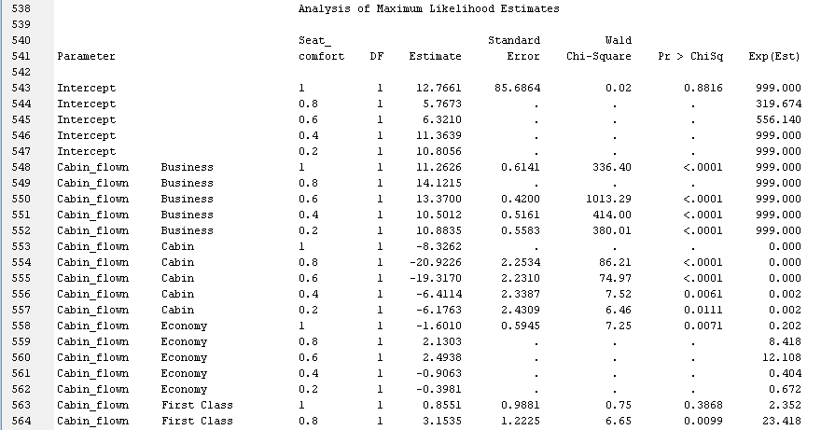

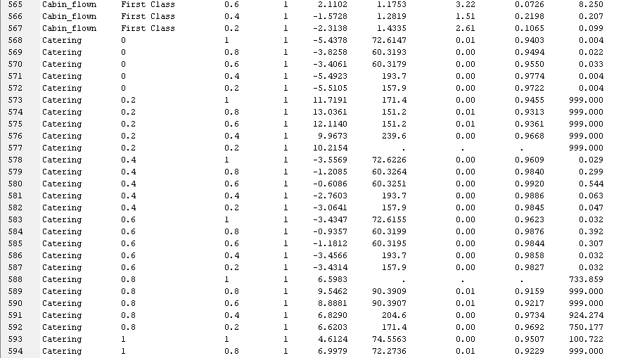

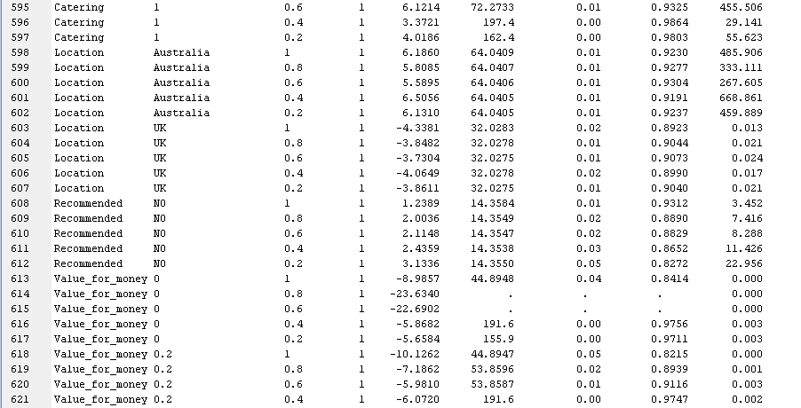

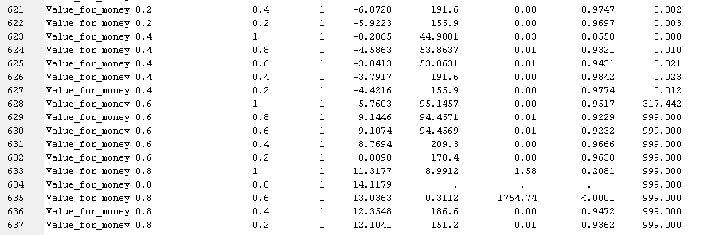

# Finding(s)

*I found that Business class is statistically impact the quality of seat comfort*

# Recommendation(s)

*I would recommend airline ticket to promote business class for the best seat comfort*

# What is at stake?

**What are the benefits if your audience acts in the way that you want them to?**

The benefit is that they get to use their travel points and the anxiety of travel a lot and long distance on an uncomfortable seat and if they willing spend to upgrade from cabin and economy class, it will help generate more money for airline ticket agents

**What are the risks if they do not?**

They will more likely to experience bad time traveling with poor quality seat comfort

# References